

**Introduction**

Urban sprawl is defined as the rapid expansion of the geographic extent of cities and towns. It has become a major concern for policymakers, city planners and environmentalists in recent times. As populations continue to grow, cities are faced with significant challenges in accommodating this growth alongside establishing sustainable development and preserving natural ecosystems. Alberta’s cities of Edmonton and Calgary have, and continue to, experience rapid urbanisation. With a substantial growth in population and greater amounts of land use, the cities have resorted to altering their housing development patterns to prioritise urban sprawl, resulting in vast swaths of detached single family homes on the peripheries of each city, most of which replaced high-quality farmland (Martellozzo et al., 2014; Sun et al., 2007).

Calgary and Edmonton are the two largest cities in Alberta, and the fourth and fifth largest in Canada, both cities have experienced significant growth in recent years. Between the years of 2011 and 2021, Edmonton’s population grew by 22.37%, while Calgary’s population grew by 22.78%. This rapid growth has been fuelled by Alberta’s thriving oil and gas industry, attracting increased investment and generating countless employment opportunities. The rapid expansion of both cities has led to increased urbanisation, with new communities being developed on the edges of each city’s urban core. The many challenges with this type of growth cause city planners and policy makers to struggle in managing the environmental and economic consequences of urban sprawl.

It is important to study and understand the factors that contribute to urban sprawl due to its extensive effects on our society and specifically the environment. The rapid expansion of cities and urban areas can result in increased greenhouse gas emissions, habitat loss to natural species and the loss of prime agricultural lands, while also having socioeconomic effects and possibly impacting the overall quality of life in these areas. The need to address urban sprawl is particularly crucial in the context of climate change, as most cities are working towards reducing their environmental footprint which can be done with sustainable development.

Research on urban sprawl in Canada has focused on larger metropolitan areas, such as the Greater Toronto Area, Greater Montreal, and Metro Vancouver. Consequently, there is less knowledge about the effects of socioeconomic factors on areas that have seen large amounts of growth more recently, such as Calgary and Edmonton. Since both of these cities are major economic centres of Alberta, they are particularly important. Their development patterns have been shaped by the province’s resource-based economy (Meligrana and Skaburskis, 2005).

This project examines socioeconomic factors driving urban sprawl in Calgary and Edmonton, with a focus on population, residential tax, median income, and unemployment rate. Since Edmonton and Calgary are located in a similar geographic area within the same province, with similar populations, environmental factors, and development style, it will be ideal to compare and analyse how these factors are influencing the growth of each city, collectively and independently, by understanding the correlation between urban sprawl and a selection of socioeconomic factors.

Based on previous studies, a correlation between urban sprawl and the aforementioned factors is evident, as these factors collectively contribute to urban sprawl. An increase in population income leads to a higher demand for larger housing properties, which contributes to the construction of single-use low-density residential development. Property tax policies can also affect urban sprawl by incentivizing development on the peripheries of a city, where tax rates are more favourable due to land values being lower (Brueckner, 2000). Rapid population growth can also create a demand for increased housing as well as infrastructure and services, which tends to result in the spatial expansion of the city (Burchfield, 2006).

With this study, we hope to reduce the knowledge gap of urban sprawl in Edmonton and Calgary, by identifying the key factors that directly relate to the cities’ accelerated growth and quantify the phenomena. By intensively analysing these factors, we can contribute to the development of effective policies and strategies to abate the negative consequences of urban sprawl and promote sustainable development in cities.

**Methodology**

Landsat 8/9 Level 2 Collection imagery was acquired from USGS Earth explorer for Edmonton and Calgary. The imagery was acquired for the years of 2013, 2017, and 2022 for both cities. Since urban development happens slowly, a larger interval between the years was chosen to be compared so that there is a more noticeable change in the urban land cover. Due to a lack of clouds and snow, imagery was collected during summer months, namely July and September. No georeferencing was performed for the images as Landsat images come already georeferenced. No atmospheric correction was needed on the images since Landsat Level 2 products come atmospherically corrected. Landsat 8-9 was chosen for the analysis because it has the required imagery and a decent resolution. The use of satellite imagery from Sentinel, which would have provided a higher resolution, was not possible because data was not available for the period of study.

In order to perform analysis on Calgary and Edmonton, the area in each image which fell in their respective city boundaries had to be extracted. To do this, a boundary shapefile for both cities was used to extract the area from the raw Landsat images. After the extraction, the blue, green, red and NIR bands were stacked so that it would be easier to view the imagery in both True Colour Composite (TCC) and False Colour Composite (FCC) while classifying.

Each processed image for Edmonton and Calgary was classified using ERDAS Imagine. The classification method was minimum likelihood supervised classification. Supervised classification was chosen due to the ability to choose training sites that the classification would be based off of. Urban sprawl is what is being studied, so it is important that the urban class is defined clearly using training sites. Initially two other land cover classes were chosen to be classified besides urban, those being suburban and “other.” The suburban land cover was anticipated to change to urban, and the other land cover was meant to encompass all other land cover types in the two cities, since they are not the main focus. When supervised classification was attempted with these land cover classes in mind, the “other” class was not properly classifying the intended areas. Likely due to the fact that the training sites for the “other” class included many different land cover classes with extremely different pixel values were being averaged, which explains why the classification was poor. Instead, four other land cover classes were classified. This also gives better context to the change of urban land cover over time. Suburban, vegetation, water and bare soil are the other four classes chosen as they appeared to be the most dominant land cover classes in both Edmonton and Calgary, excluding urban land cover.

Accuracy assessment was conducted for each supervised classification image, using ArcGIS Pro. Roughly sixty-five points were created using the stratified random sample method to ensure the classification for each class was tested relative to the space it covers on each classification map. The ground truth for each point was inputted manually while referencing the original Landsat images in false colour composite. The following figures show the confusion matrix calculated in ArcGIS Pro for each image.

After performing supervised classification, the classes were converted to polygons in ArcGIS Pro to determine their respective areas. The areas in square kilometres of each class were then calculated and expressed as percentages of the total area within the city boundaries. This was done to enable comparison of the urban and suburban areas of the two cities by disregarding the difference between their total areas.

Table 1: Confusion matrix for accuracy assessment of August, 24, 2013 Calgary classification

| Landcover class | Urban | Suburban | Vegetation | Water | Bare Soil | Total | User Accuracy | Kappa |
| --- | --- | --- | --- | --- | --- | --- | --- | --- |
| Urban | 5 | 4 | 0 | 0 | 2 | 11 | 45% | 0 |
| Suburban | 2 | 16 | 0 | 0 | 1 | 19 | 84% | 0 |
| Vegetation | 0 | 0 | 10 | 0 | 0 | 10 | 100% | 0 |
| Water | 0 | 0 | 0 | 10 | 0 | 10 | 100% | 0 |
| Bare Soil | 0 | 4 | 3 | 0 | 3 | 10 | 30% | 0 |
| Total | 7 | 24 | 13 | 10 | 6 | 60 | 0 | 0 |
| Producer Accuracy | 71% | 67% | 77% | 100% | 50% | 0 | 73% | 0 |
| Kappa | 0 | 0 | 0 | 0 | 0 | 0 | 0 | 65% |

Table 2: Confusion matrix for accuracy assessment of September 25, 2013 Edmonton classification

|  |  |  |  |  |  |  |  |  |
| --- | --- | --- | --- | --- | --- | --- | --- | --- |
| Landcover class | Urban | Suburban | Vegetation | Water | Bare Soil | Total | User Accuracy | Kappa |
| Urban | 7 | 0 | 0 | 0 | 1 | 8 | 88% | 0 |
| Suburban | 1 | 14 | 3 | 0 | 0 | 18 | 78% | 0 |
| Vegetation | 0 | 0 | 8 | 0 | 1 | 9 | 89% | 0 |
| Water | 1 | 0 | 0 | 8 | 0 | 9 | 89% | 0 |
| Bare Soil | 2 | 0 | 0 | 0 | 4 | 6 | 67% | 0 |
| Total | 11 | 14 | 11 | 8 | 6 | 50 | 0 | 0 |
| Producer Accuracy | 64% | 100% | 73% | 100% | 67% | 0 | 82% | 0 |
| Kappa | 0 | 0 | 0 | 0 | 0 | 0 | 0 | 65% |

Table 3: Confusion matrix for accuracy assessment of July 2, 2017 Edmonton classification

|  |  |  |  |  |  |  |  |  |
| --- | --- | --- | --- | --- | --- | --- | --- | --- |
| Landcover class | Urban | Suburban | Vegetation | Water | Bare Soil | Total | User Accuracy | Kappa |
| Urban | 8 | 1 | 0 | 0 | 1 | 10 | 80% | 0 |
| Suburban | 1 | 13 | 2 | 0 | 3 | 19 | 68% | 0 |
| Vegetation | 0 | 1 | 14 | 0 | 0 | 15 | 93% | 0 |
| Water | 0 | 0 | 0 | 9 | 1 | 10 | 90% | 0 |
| Bare Soil | 3 | 4 | 2 | 0 | 1 | 10 | 10% | 0 |
| Total | 12 | 19 | 18 | 9 | 6 | 64 | 0 | 0 |
| Producer Accuracy | 67% | 68% | 78% | 100% | 17% | 0 | 70% | 0 |
| Kappa | 0 | 0 | 0 | 0 | 0 | 0 | 0 | 62% |

Table 4: Confusion matrix for accuracy assessment of July 2, 2017 Calgary classification

|  |  |  |  |  |  |  |  |  |
| --- | --- | --- | --- | --- | --- | --- | --- | --- |
| Landcover class | Urban | Suburban | Vegetation | Water | Bare Soil | Total | User Accuracy | Kappa |
| Urban | 9 | 0 | 0 | 0 | 1 | 10 | 90% | 0 |
| Suburban | 3 | 16 | 2 | 0 | 0 | 21 | 76% | 0 |
| Vegetation | 0 | 2 | 12 | 0 | 0 | 14 | 86% | 0 |
| Water | 0 | 0 | 0 | 10 | 0 | 10 | 100% | 0 |
| Bare Soil | 1 | 3 | 4 | 0 | 2 | 10 | 20% | 0 |
| Total | 13 | 21 | 18 | 10 | 3 | 65 | 0 | 0 |
| Producer Accuracy | 69% | 76% | 67% | 100% | 67% | 0 | 75% | 0 |
| Kappa | 0 | 0 | 0 | 0 | 0 | 0 | 0 | 68% |

Table 5: Confusion matrix for accuracy assessment of September 26, 2022 Edmonton Classification

|  |  |  |  |  |  |  |  |  |
| --- | --- | --- | --- | --- | --- | --- | --- | --- |
| Landcover class | Urban | Suburban | Vegetation | Water | Bare Soil | Total | User Accuracy | Kappa |
| Urban | 7 | 1 | 0 | 0 | 2 | 10 | 70% | 0 |
| Suburban | 8 | 10 | 8 | 0 | 3 | 29 | 34% | 0 |
| Vegetation | 0 | 0 | 9 | 0 | 1 | 10 | 90% | 0 |
| Water | 0 | 1 | 2 | 6 | 1 | 10 | 60% | 0 |
| Bare Soil | 0 | 0 | 0 | 0 | 10 | 10 | 100% | 0 |
| Total | 15 | 12 | 19 | 6 | 17 | 69 | 0 | 0 |
| Producer Accuracy | 47% | 83% | 47% | 100% | 59% | 0 | 61% | 0 |
| Kappa | 0 | 0 | 0 | 0 | 0 | 0 | 0 | 51% |

Table 6: Confusion matrix for accuracy assessment of September 26, 2022 Calgary classification

|  |  |  |  |  |  |  |  |  |
| --- | --- | --- | --- | --- | --- | --- | --- | --- |
| Landcover class | Urban | Suburban | Vegetation | Water | Bare Soil | Total | User Accuracy | Kappa |
| Urban | 10 | 0 | 0 | 0 | 0 | 10 | 100% | 0 |
| Suburban | 4 | 19 | 4 | 0 | 0 | 27 | 70% | 0 |
| Vegetation | 0 | 2 | 7 | 0 | 1 | 10 | 70% | 0 |
| Water | 1 | 0 | 0 | 8 | 1 | 10 | 80% | 0 |
| Bare Soil | 2 | 0 | 1 | 0 | 7 | 10 | 70% | 0 |
| Total | 17 | 21 | 12 | 8 | 9 | 67 | 0 | 0 |
| Producer Accuracy | 59% | 90% | 58% | 100% | 78% | 0 | 76% | 0 |
| Kappa | 0 | 0 | 0 | 0 | 0 | 0 | 0 | 69% |

**Results**

Classification maps for Edmonton and Calgary over our chosen 3 years - 2013, 2017 and 2022 are represented in Figures 1-6. This is done to look at outliers and where certain classes are most prevalent. Furthermore, Tables 7-11 include information such as the areas of the classes in Calgary and Edmonton and socioeconomic factors taken from the Government of Alberta. Lastly, Figures 7-10 illustrate the changes between the socioeconomic factors from 2013 to 2022 as well as looking at the differences in percentages of urban and suburban areas in both cities over the same ten years.

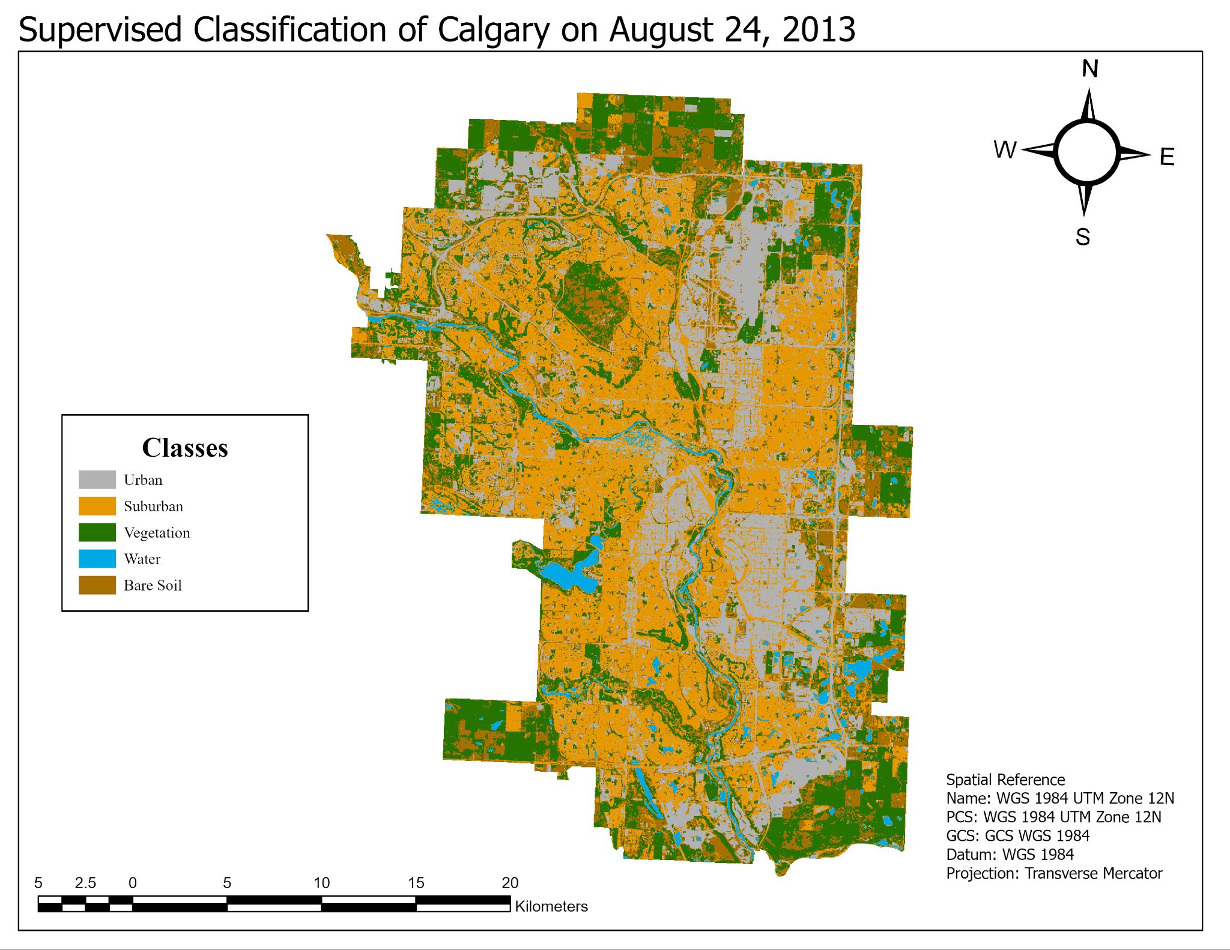

Figure 1: Supervised classification map of Calgary, AB on August 24, 2013

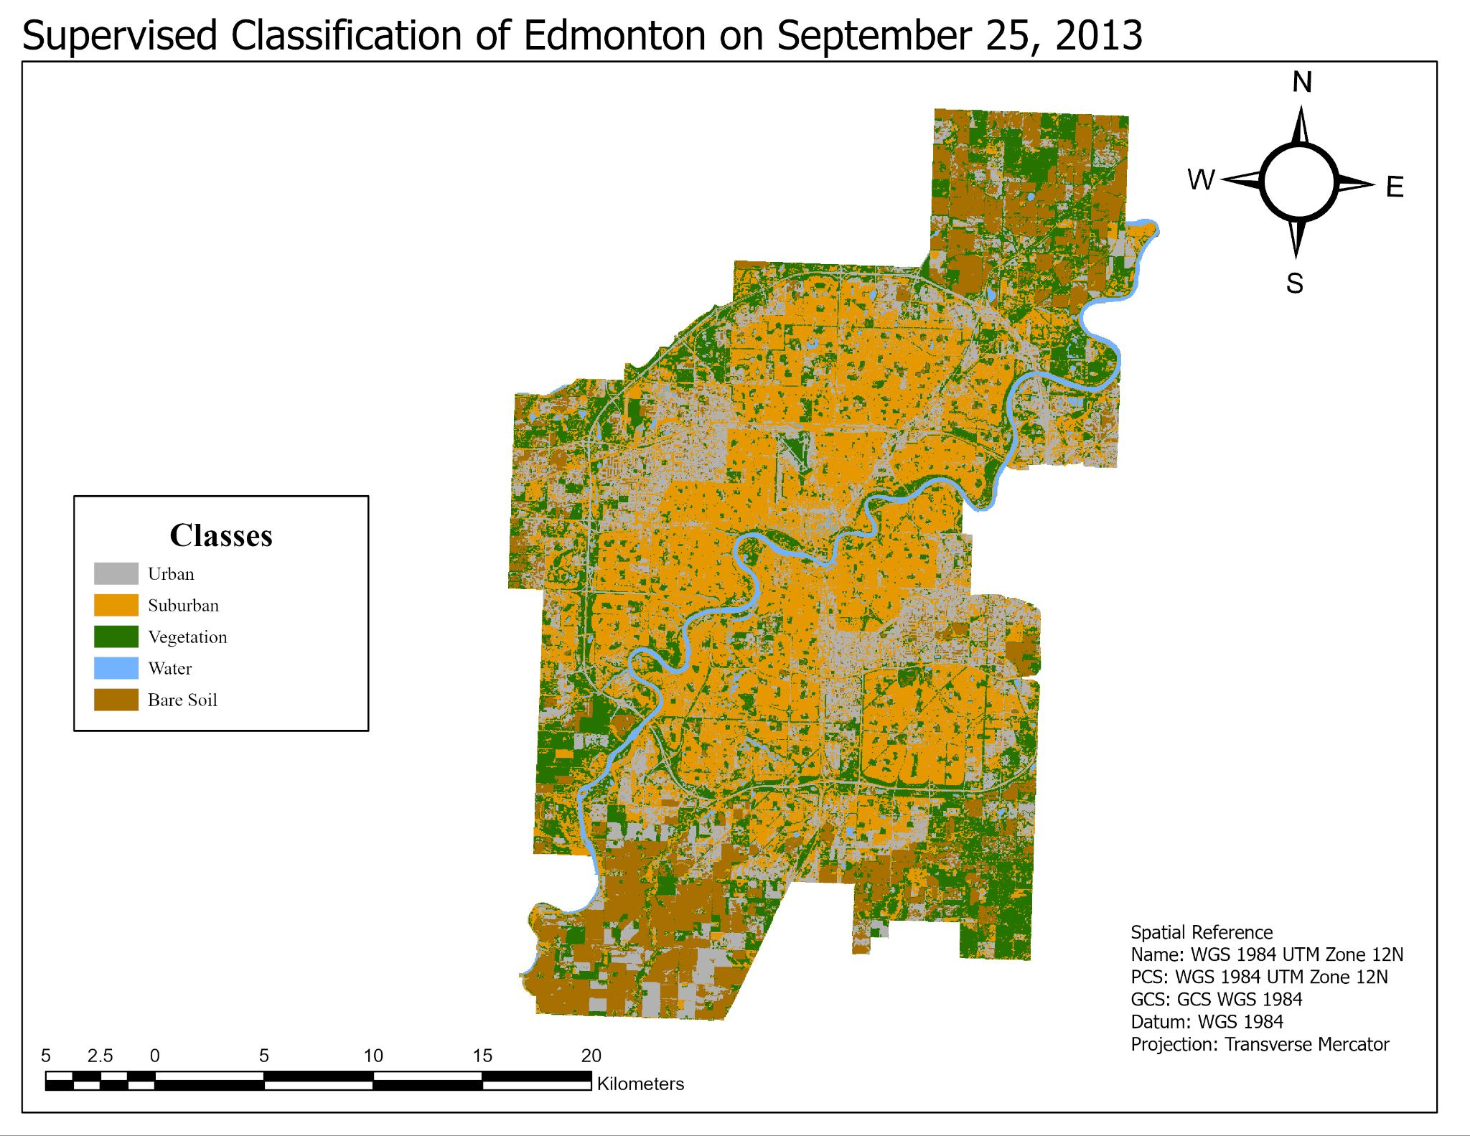

Figure 2: Supervised classification map of Edmonton, AB on September 25, 2013

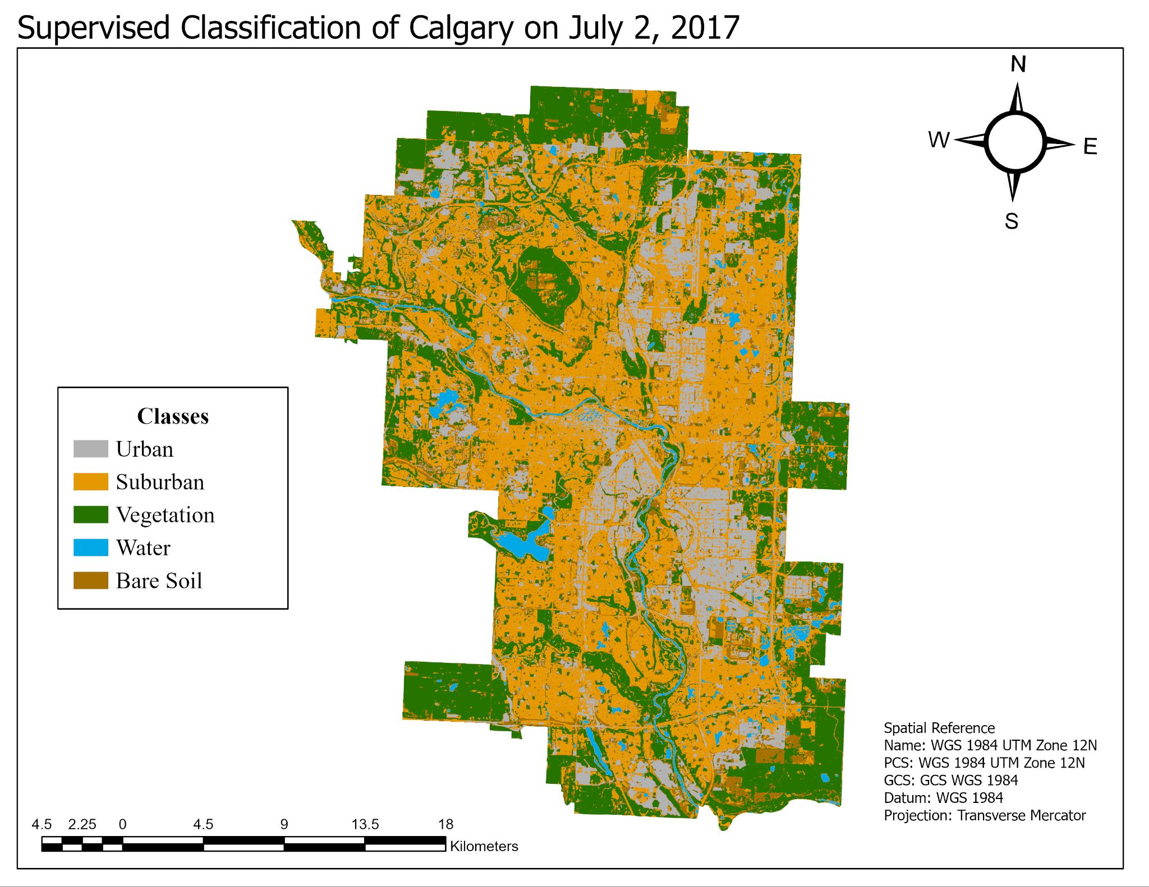

Figure 3: Supervised classification map of Calgary, AB on July 2, 2017

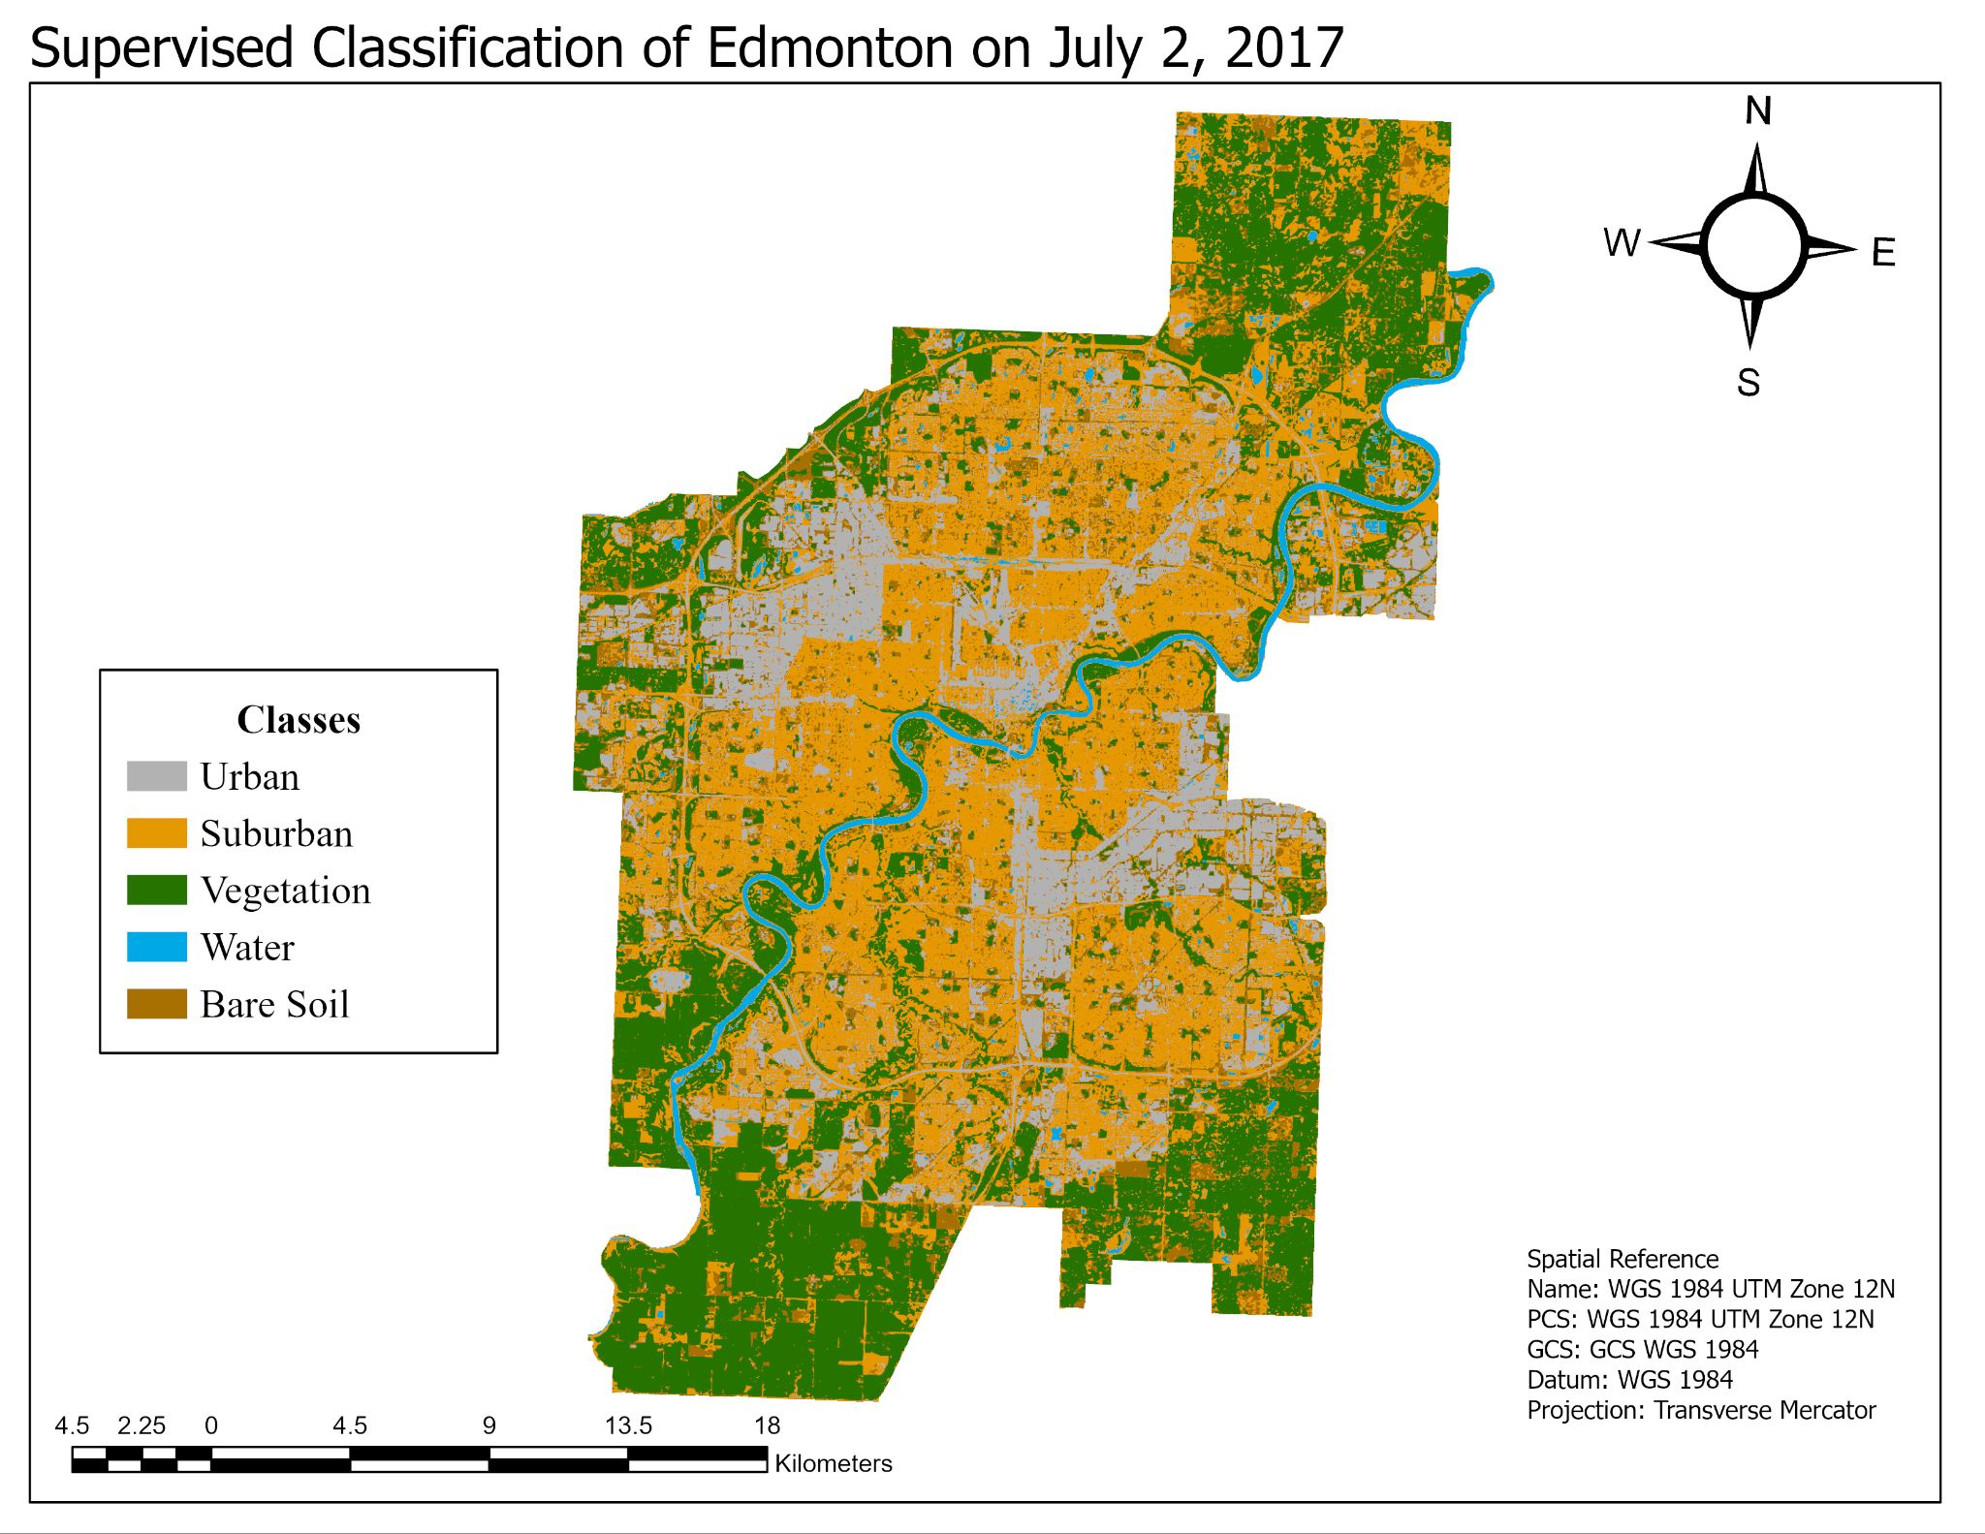

Figure 4: Supervised classification map of Edmonton, AB on July 2, 2017

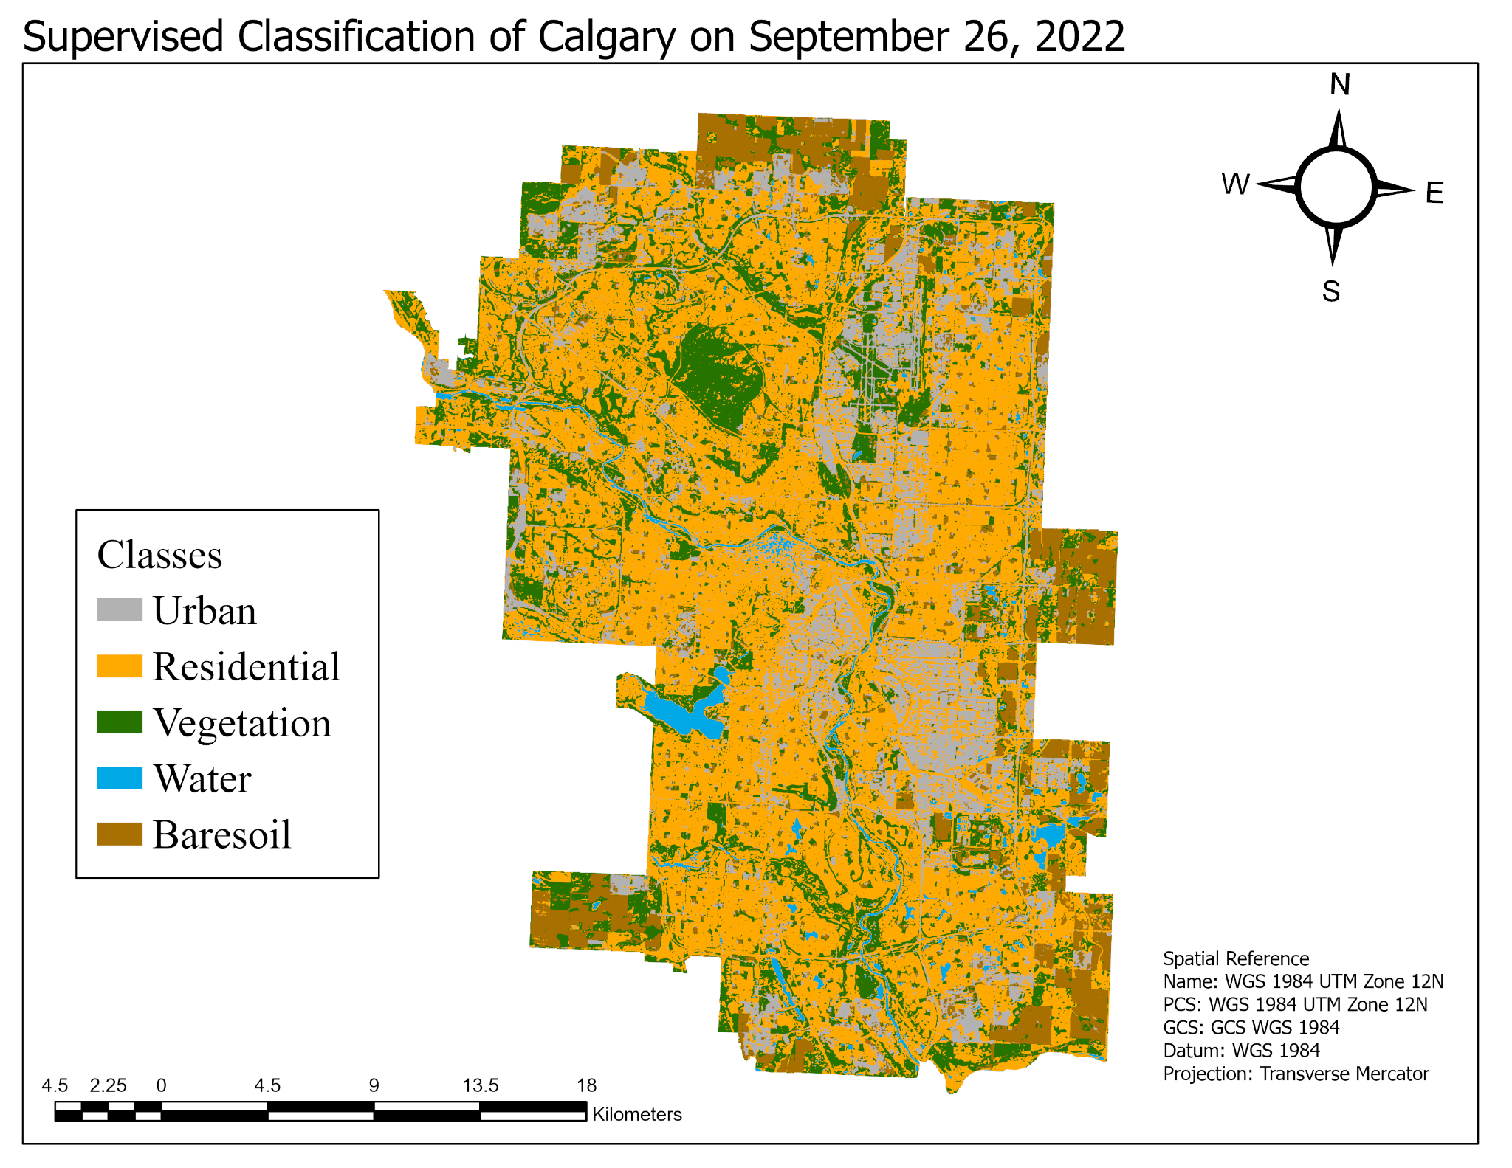

Figure 5: Supervised classification map of Calgary, AB on September 26, 2022

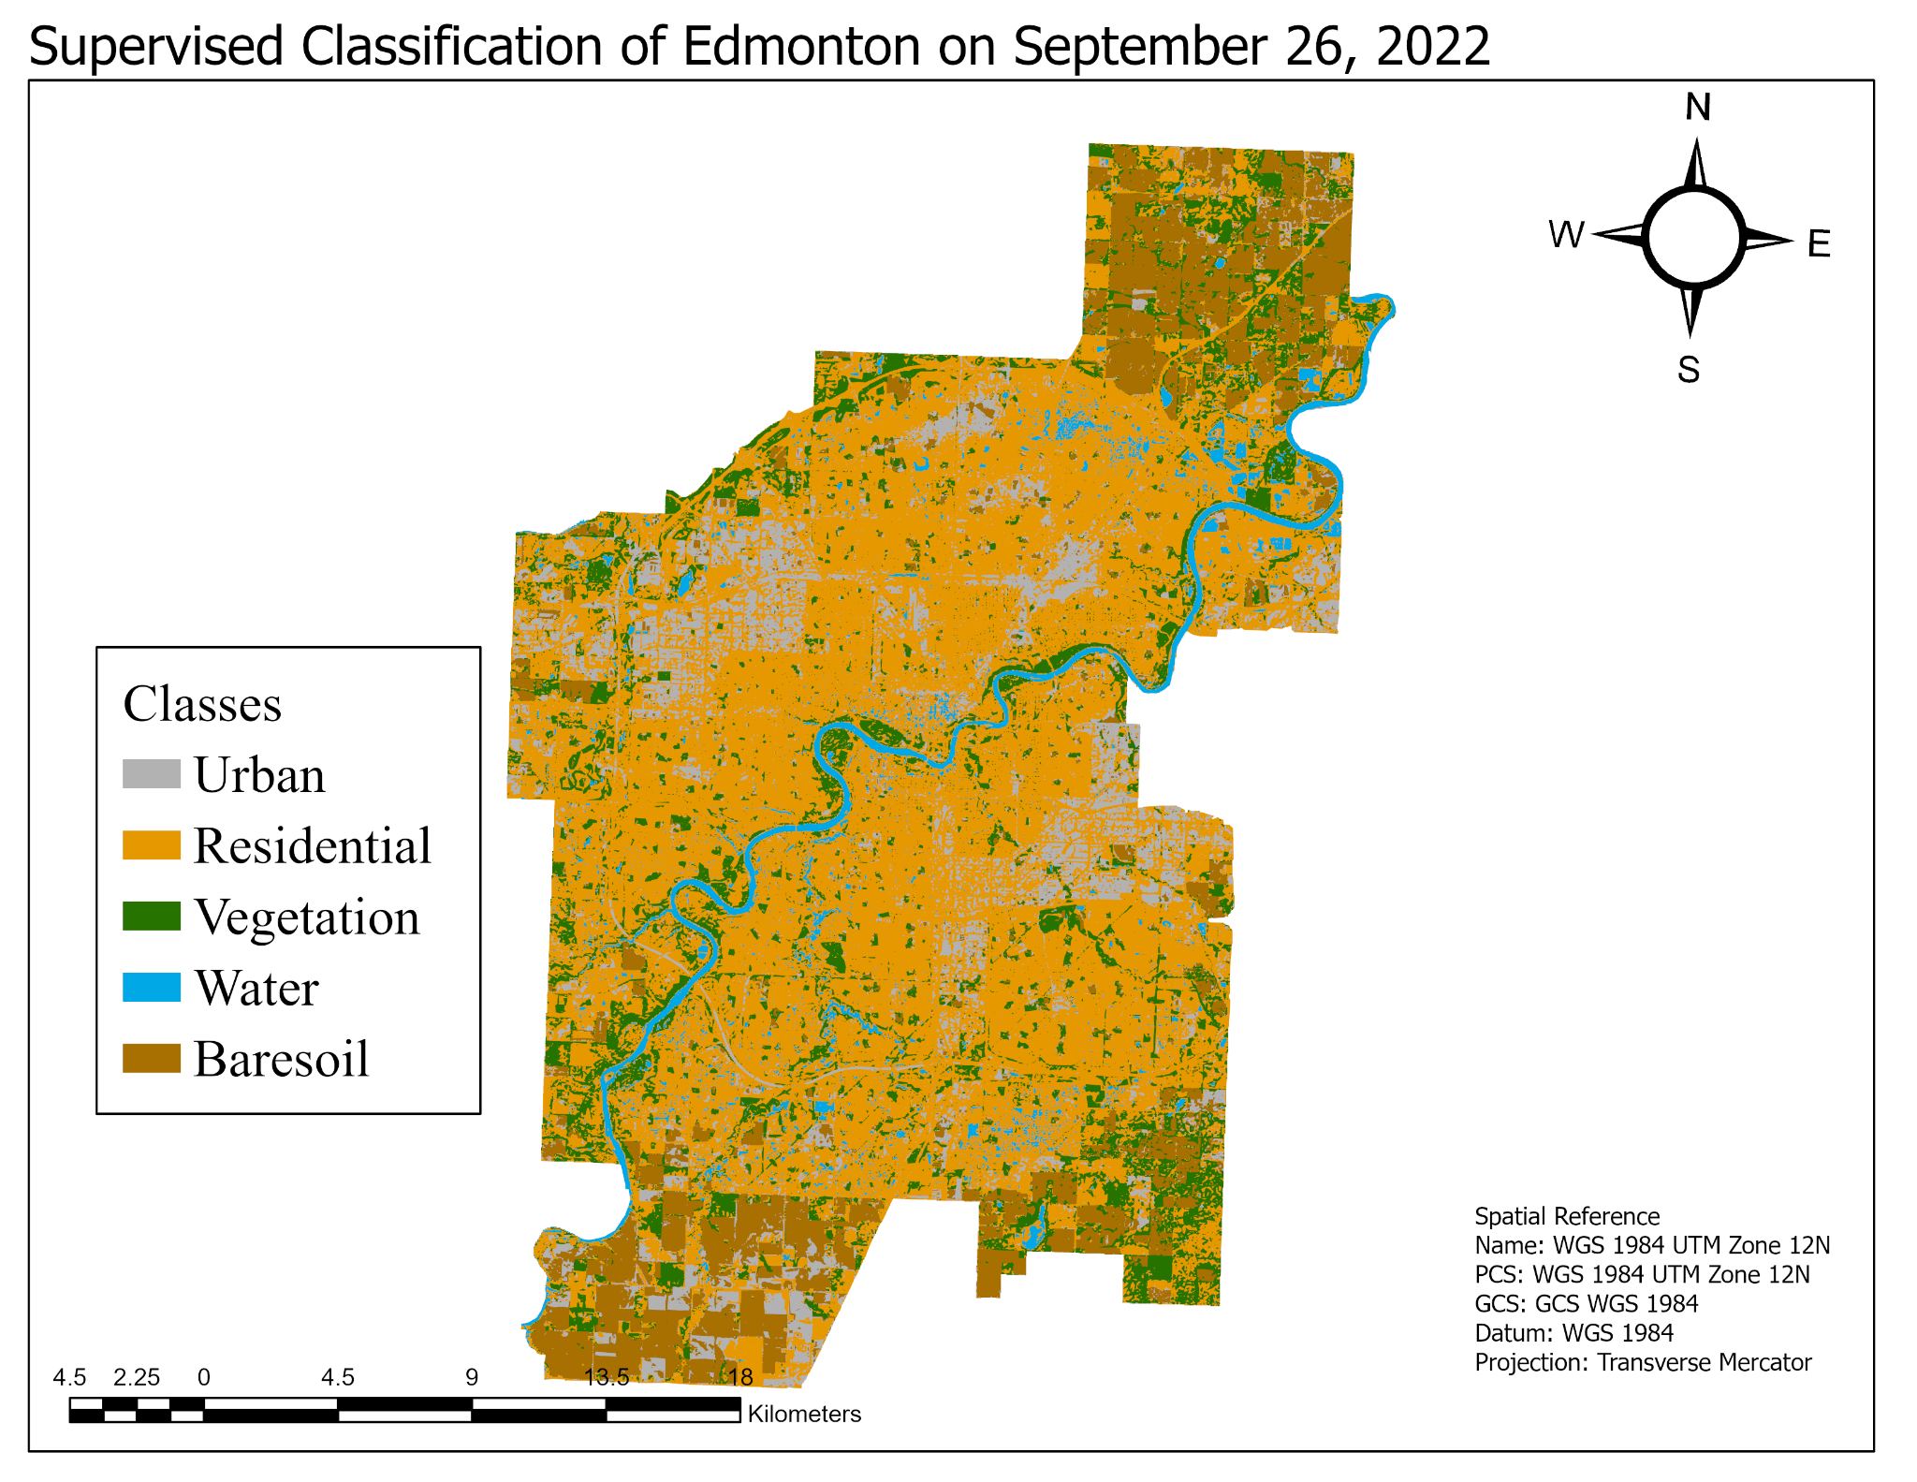

Figure 6: Supervised classification map of Edmonton, AB on September 26, 2022

Table 7: Area of different land cover classes from Calgary classification maps from 2013-2022

|  |  |  |  |
| --- | --- | --- | --- |
| Land cover classes | Calgary 2013 Area (km²) | Calgary 2017 Area (km²) | Calgary 2022 Area (km²) |
| Suburban | 319.834 | 368.95 | 457.47 |
| Urban | 182.04 | 119.71 | 111.79 |
| Vegetation | 170.171 | 238.42 | 174.06 |
| Bare Soil | 149.177 | 96.47 | 85.29 |
| Water | 27.4109 | 25.09 | 20.03 |
| Total Area | 848.6329 | 848.64 | 848.64 |

Table 8: Area of different land cover classes from Calgary classification maps from 2013-2022 by proportion

|  |  |  |  |  |  |
| --- | --- | --- | --- | --- | --- |
| Land cover classes | Proportion of total Calgary 2013 area | Proportion of total Calgary 2017 area | Percentage change 2013-2017 | Proportion of total Calgary 2022 area | Percentage change 2017-2022 |
| Suburban | 37.69% | 43.48% | 15.36% | 53.91% | 23.99% |
| Urban | 21.45% | 14.11% | -34.24% | 13.17% | -6.62% |

Table 9: Area of different land cover classes from Edmonton classification maps from 2013-2022

|  |  |  |  |
| --- | --- | --- | --- |
| Land cover classes | Edmonton 2013 Area (km²) | Edmonton 2017 Area (km²) | Edmonton 2022 Area (km²) |
| Suburban | 310.999 | 308.37 | 462.19 |
| Urban | 150.617 | 113.85 | 77.87 |
| Vegetation | 181.4 | 240.72 | 108.05 |
| Bare Soil | 116.753 | 100.61 | 101.44 |
| Water | 23.283 | 19.53 | 33.5 |
| Total Area | 783.052 | 783.08 | 783.05 |

Table 10: Area of different land cover classes from Edmonton classification maps from 2013-2022 by proportion

|  |  |  |  |  |  |
| --- | --- | --- | --- | --- | --- |
| Land cover classes | Proportion of total Edmonton 2013 area | Proportion of total Edmonton 2017 area | Percentage change 2013-2017 | Proportion of total Edmonton 2022 area | Percentage change 2017-2022 |
| Suburban | 39.72% | 39.38% | -0.85% | 59.02% | 49.89% |
| Urban | 19.23% | 14.54% | -24.41% | 9.94% | -31.60% |

Table 11: Census data of Socioeconomic factors for Calgary and Edmonton from 2011-2021

|  |  |  |  |  |
| --- | --- | --- | --- | --- |
|  | Median Family Income | Residential taxes | Unemployment rate | Population |
| Calgary 2011 | $101,260 | 0.61% | 4.80% | 1,311,740 |
| Calgary 2016 | $102,060 | 0.65% | 8.80% | 1,374,450 |
| Percentage change Calgary 2011-2016 | 0.79% | 6.56% | 83.33% | 4.78% |
| Calgary 2021 | $109,520 | 0.71% | 6.20% | 1,482,050 |
| Percentage change Calgary 2016-2021 | 7.31% | 9.23% | -29.55% | 7.83% |
| Edmonton 2011 | $98,480 | 0.80% | 4.70% | 1,233,720 |
| Edmonton 2016 | $101,190 | 0.85% | 8.30% | 1,307,220 |
| Percentage change Edmonton 2011-2016 | 2.75% | 6.12% | 76.60% | 6.82% |
| Edmonton 2021 | $107,450 | 0.94% | 5.90% | 1,396,110 |
| Percentage change Edmonton 2016-2021 | 6.19% | 10.59% | -28.92% | 6.80% |

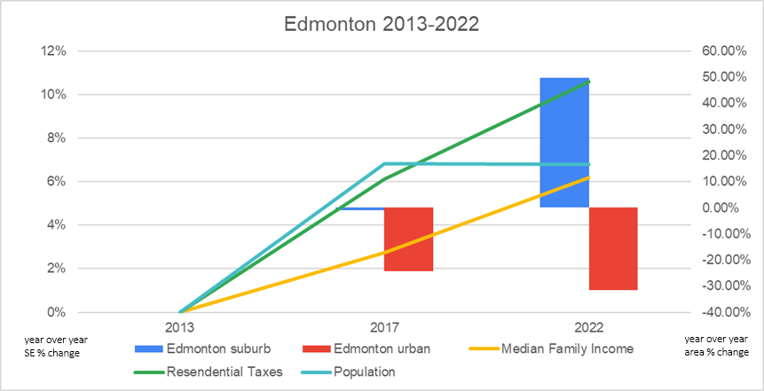

Figure 7: Chart illustrating year over year changes of select socioeconomic factors and urban growth in Edmonton from 2013-2022.

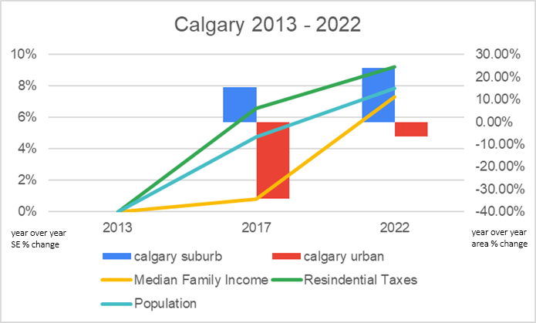

Figure 8: Chart illustrating year over year changes of select socioeconomic factors and urban growth in Calgary from 2013-2022.

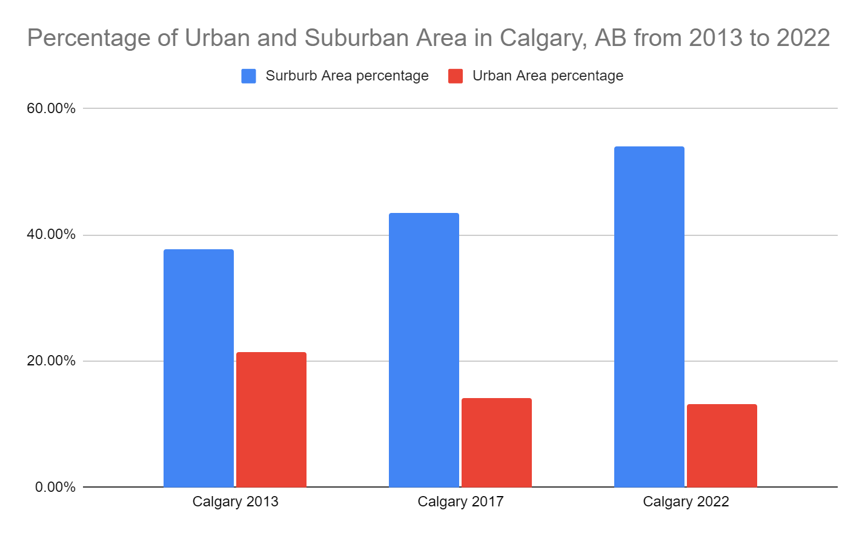

Figure 9: Chart illustrating the percentage of urban and suburban areas in Calgary, AB from 2013-2022.

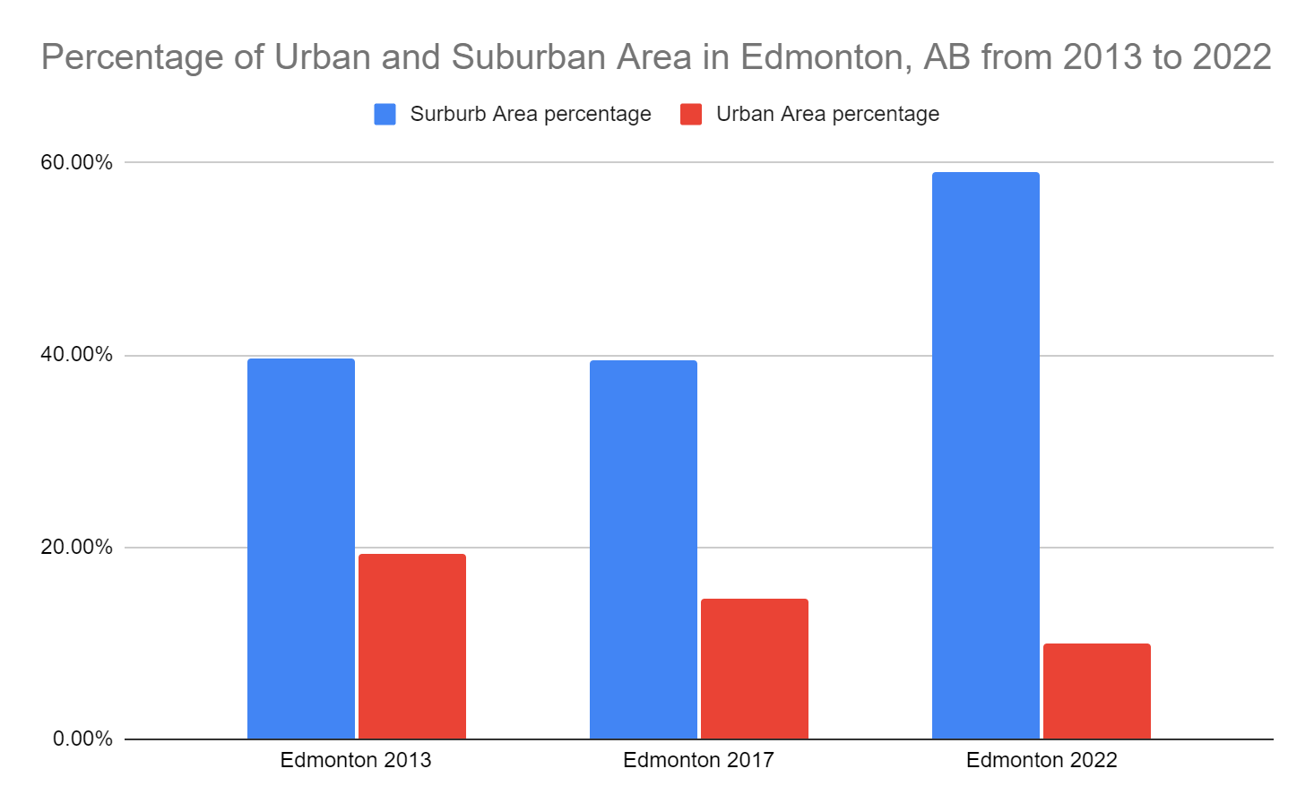

Figure 10: Chart illustrating the percentage of urban and suburban areas in Edmonton, AB from 2013-2022.

**Discussion**

This study provides insights into the urbanisation patterns of Edmonton and Calgary over the past decade, highlighting significant changes in urban and suburban land cover and their spatial distribution. From the findings, it can be seen that the proportion of suburban areas has increased for both Calgary and Edmonton from 2013-2022 (Figure 9 and Figure 10). The increase in suburban area is more linear for Calgary whereas for Edmonton, there was almost no change in suburban area from 2013-2017 but a huge jump in the suburban area from 2017-2022. It is possible that the increase in suburban area for both cities is due to the rapid increase in populations in both cities. Since both Calgary and Edmonton still have farmland to expand on the periphery of the city, most houses are built as suburban subdivisions, and are a major contributing factor to the suburban class on our classification maps. As shown in figures 1 and 5, toward the south of Calgary, a lot of the former industrial land got reclassified in 2022 as suburban, now being formed of mostly detached houses.

It was anticipated that there would be an increase in the proportion of urban land cover; however, the results portrayed in Figure 9 and Figure 10 demonstrate a decline in the proportion of urban land cover for both cities during the period 2013-2022. This decline may be attributed to the replacement of urban land cover by other expanding classes such as suburban land cover. Alternatively, it could be the result of misclassification of urban land cover arising from suboptimal selection of training sites. The accuracy assessment tables for the 2022 classification (Table 5 and Table 6) indicate that the producer's accuracy for the urban class is relatively low (49 and 57 percent, respectively). This implies that the urban class may have been misclassified, leading to discrepancies between the actual urban area and the classified urban area. The suburban class had a low user accuracy across all 6 tables (Table 1-6). This can be attributed to there being a lot of trees in older suburban areas where tree cover would be classified as vegetation instead of suburban. Or, in newer developments with a lot of roads, ERDAS decided to classify such an area as urban when in reality it is suburban houses.

The rate of change of socioeconomic factors was plotted over several years and visual aids were created to facilitate the investigation into their correlation with changes in urban and suburban spaces. A simple visual inspection revealed that changes in unemployment rates were not correlated with any changes in either city's growth rates. As a result, this socioeconomic factor was removed from the analysis to better represent potential trends among other factors (refer to figures 7 and 8).

Figure 8 illustrated a clear positive correlation between population growth, rising income, and increasing residential property taxes with the rates of suburbanization in Calgary. Conversely, the same group of socioeconomic factors displayed a negative correlation with the urban growth rate. A similar trend was observed in Edmonton, as depicted in Figure 7. However, a discrepancy was identified in the 2016 data, where socioeconomic factors experienced a notable increase while both urban and suburban areas saw a moderate decrease. This could be attributed to human errors, as the overall data from 2021 suggested that the same correlation between socioeconomic factors and city growth rates that exists in Calgary also exists in Edmonton.

It is important to understand that identifying the existence of a correlation is not sufficient to determine the strength of each correlation, as only three data points are available. Further research and analysis are recommended to discern this information by generating a regression line.

According to a study on International Tax and Public Finance, published by Brueckner and Kim (2003), rising property tax rates may contribute to suburban sprawl in cities such as Calgary and Edmonton. The article found that property taxes can "encourage inefficient spatial expansion of cities, particularly in cases where housing and non-housing goods are poor substitutes." Brueckner and Kim (2003). As a result, it is possible that the increase in suburban areas in both cities is due in part to the increase in property tax rates in the studied years, and that the correlation which exists may not be entirely coincidental.

This study found that as population increases, urban sprawl increases. Since the effects of urban sprawl are often seen on the edges of cities, this would be the case for Calgary and Edmonton as well. With the results from this study, one can conclude that when a city is experiencing growth, more land is going to be classified as suburban. As we can see from Figures 1-6, the majority of land on the edge of the city that changed its classification from 2013 to 2022 is vegetation and farmland. This makes this report’s findings similar to those of the study by Marterllozzo which describes the substantial loss of farmland in cities that are quickly suburbanizing.

**Conclusion**

Our study shows that the proportion of suburban areas has increased whereas the proportion of urban areas has decreased for the cities of Calgary and Edmonton over the period of 2013-2022. This study also indicates that there exists a positive correlation between population growth, rising median income, and increasing residential property taxes with the rates of urbanisation and suburbanization in both cities. This report acts as an important step to analysing the growth of Calgary and Edmonton during the 2010’s and how both of the cities can control development to be more sustainable in the future. The information provided in this study could be a valuable resource for urban planners while making future decisions about expansion and the future of both cities.

**References**

BRUECKNER, J. K. (2000). Urban Sprawl: Diagnosis and Remedies. International Regional Science Review, 23(2), 160–171. <https://doi.org/10.1177/016001700761012710> (accessed 05 April, 2023).

BRUECKNER, J.K and KIM, H. A. (2003). Urban sprawl and the property tax. International Tax and Public Finance, 10, 5-23.<https://doi.org/10.1023/A:1022260512147> (accessed 05 April, 2023).

BURCHFIELD, M., OVERMAN, H. G., PUGA, D., & TURNER, M. A. (2006). Causes of Sprawl: A Portrait from Space. The Quarterly Journal of Economics, 121(2), 587–633. <https://doi.org/10.1162/qjec.2006.121.2.587> (accessed 05 April, 2023).

MARTELLOZZO, F., RAMANKUTTY, N., HALL, R.J. *et al*. (2014). Urbanization and the loss of prime farmland: a case study in the Calgary–Edmonton corridor of Alberta. <https://doi.org/10.1007/s10113-014-0658-0>(accessed 05 April, 2023).

MELIGRANA, J., SKABURSKIS, A. (2005). Extent, Location and Profiles of Continuing Gentrification in Canadian Metropolitan Areas, 1981 –2001. <https://journals.sagepub.com/doi/pdf/10.1080/00420980500185462> (accessed 05 April, 2023).

SUN, H., FORSYTHE, W. and WATERS, N. (2007). Modeling Urban Land Use Change and Urban Sprawl: Calgary, Alberta, Canada. <https://doi.org/10.1007/s11067-007-9030-y> (accessed 05 April, 2023).